Conditional Statements Within a TRIM Command

To produce address labels that have that professional look, it is useful to print the person’s title, the first name, an initial – if one exists! --, and the last name. Because the label looks “unfinished” if there are varying gaps between the name components, use the Trim function to control the output spacing. For example,

Ms. Laurie D. Smithson

looks better on a label than

Ms. Laurie D. Smithson.

Access97 uses pipes (|) within the logical IIF to perform this trim procedure. Note the following example:

=Trim([CUS_TITLE] & " " & [CUS_FNAME] &
IIf([CUS_INITIAL] Is Null," "," |[CUS_INITIAL]|. ") & [CUS_LNAME])

Access2000 will not permit the preceding trim format. If, for instance, you use the preceding trim format to print the label, the output will look like Figure 1.

Figure 1 Incorrect Label Output Format
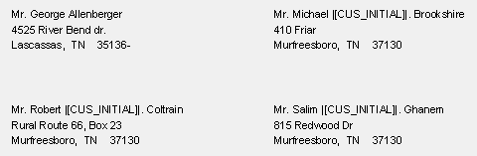

Note the inclusion of the pipes and the attribute (field) name.

To eliminate this problem, change the Trim function statement to the following:

=Trim([CUS_TITLE] & " " & [CUS_FNAME] & " "
& IIf([CUS_INITIAL] Is Null," ",[CUS_INITIAL] & ". ") & [CUS_LNAME])

This change will produce the proper label output.

